ADD VIEWER

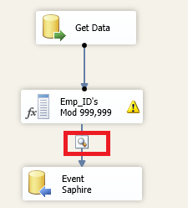

Manage Derived problems – IsNumeric

(DT_I4)(**Emp_id**) > 0 ? (DT_I4)(**Emp_id**) % 1000000 : (DT_I4)(**Emp_id**)

(DT_I4)(**Emp_id**) > 0 ? VERIFICA SI ES NUMERICO

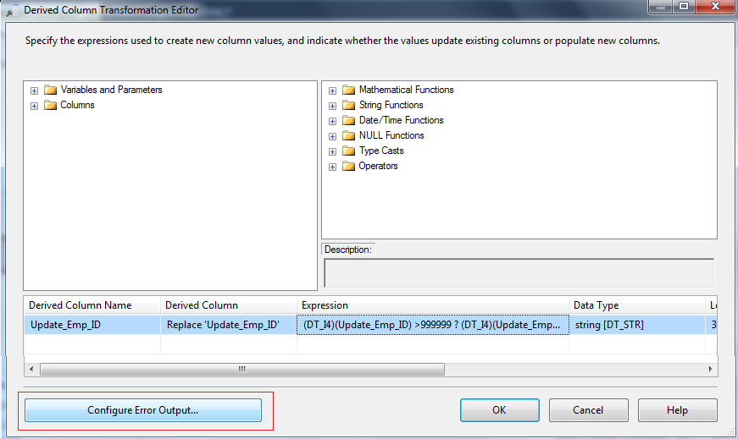

Set ignore error

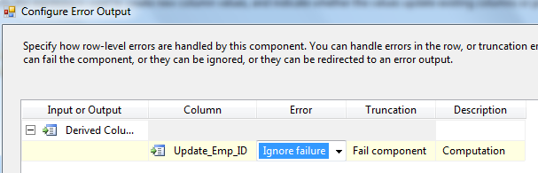

* Ignore Failure: Inserta NULL en campo error
* Redirect Row: Elimina toda la fila
* Fail Component: Aborta proceso